**SQL Questions for Project Objectives**

MARKET DYNAMICS ANALYSIS

* Total Sales by Region

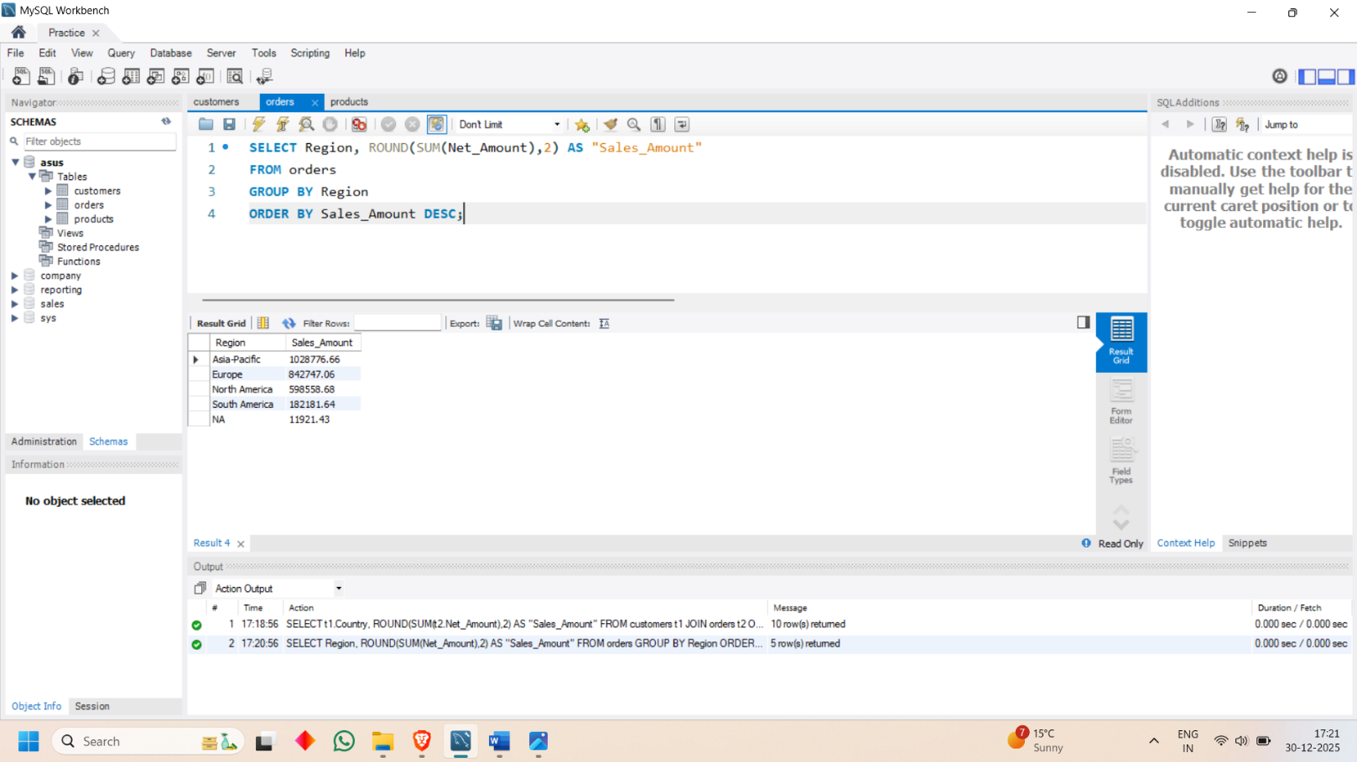

* Top 10 Countries with Highest Sales

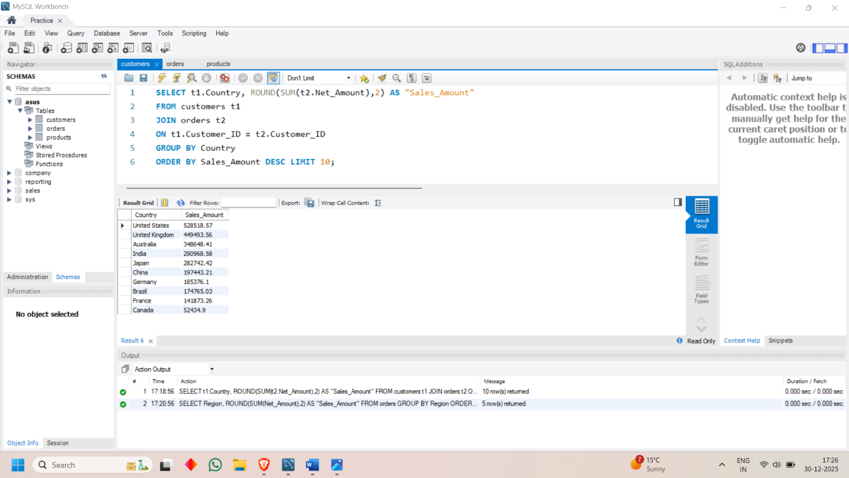

* Top 10 Cities by Sales

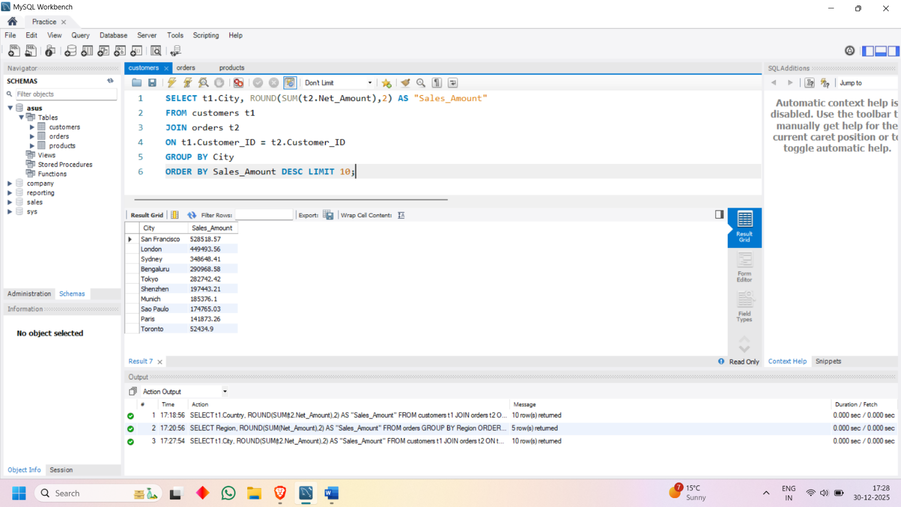

* Monthly Sales Trend

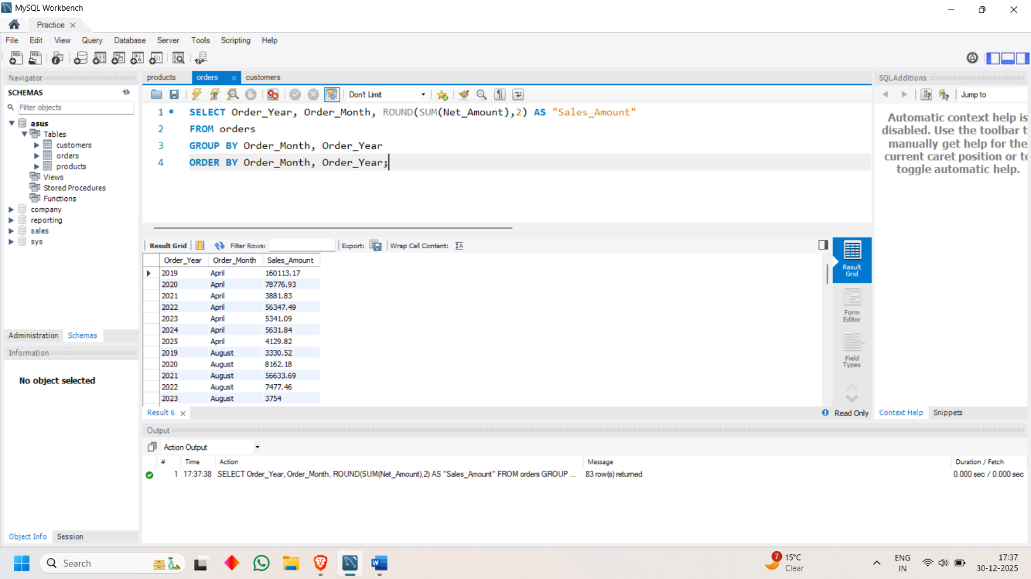

* Seasonal Trend by Region

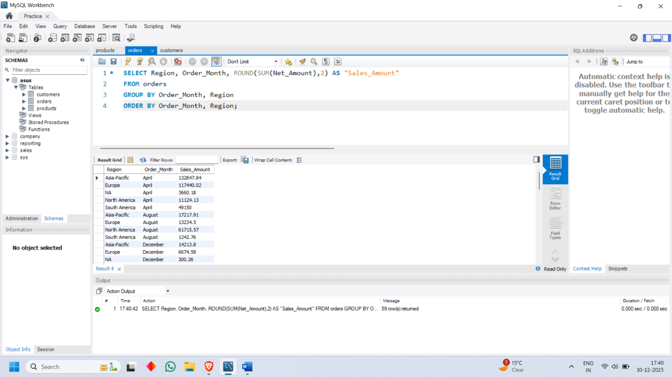

* Average Order Value by Region

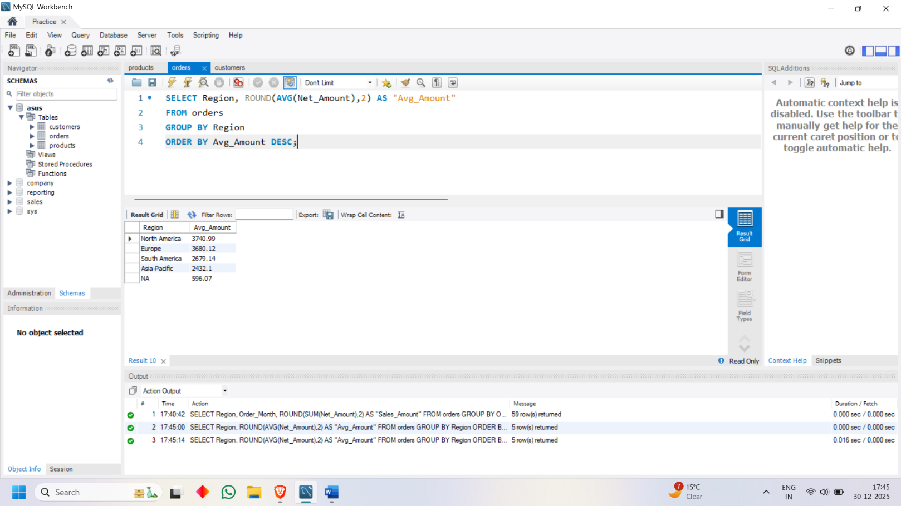

CUSTOMER ANALYSIS

* Orders by Customer Segment

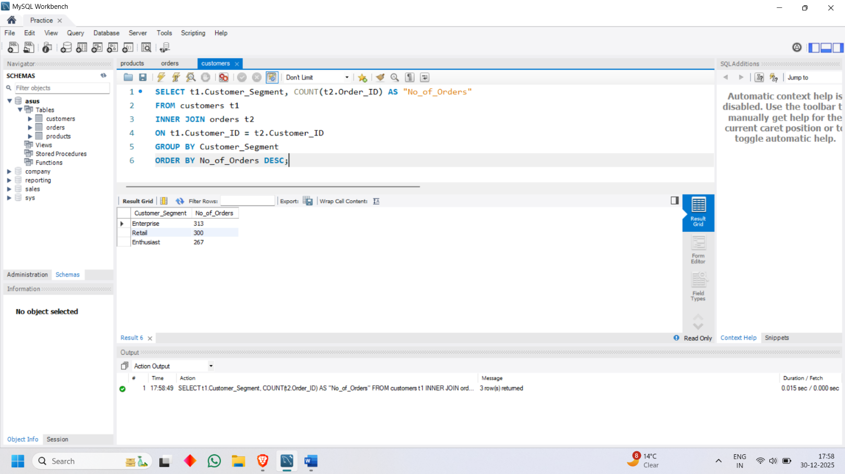

* Customers per Country

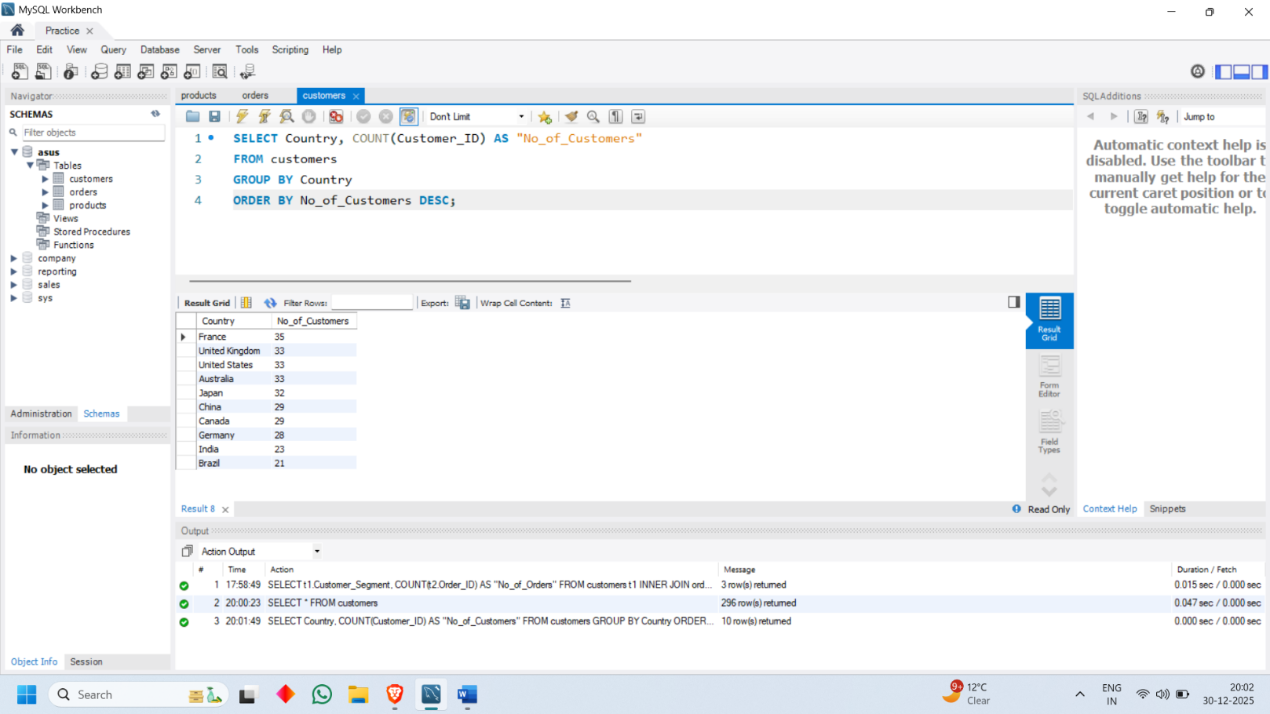

* Customer Registration Trend

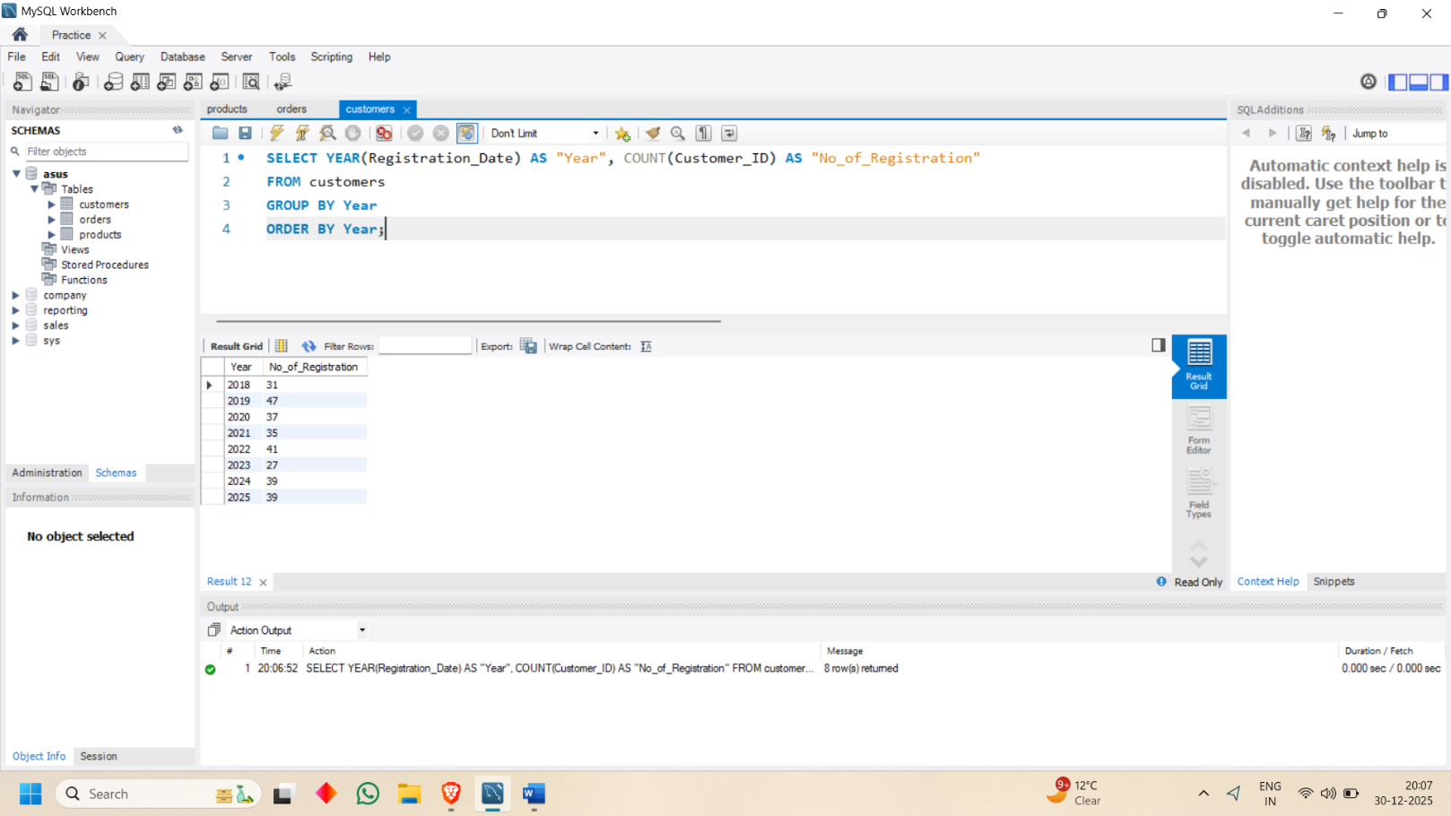

* Customer Lifetime Value (LTV)

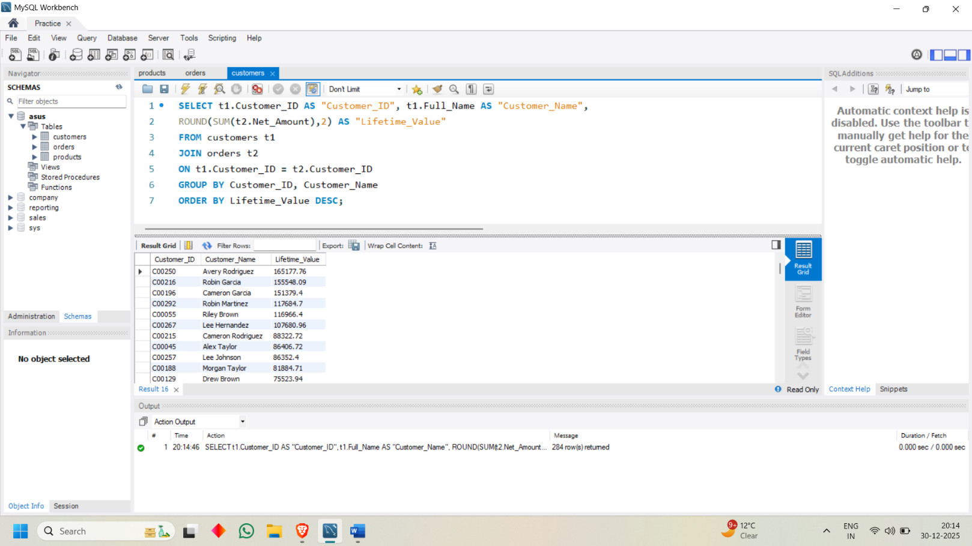

* Repeat vs One Time Customers

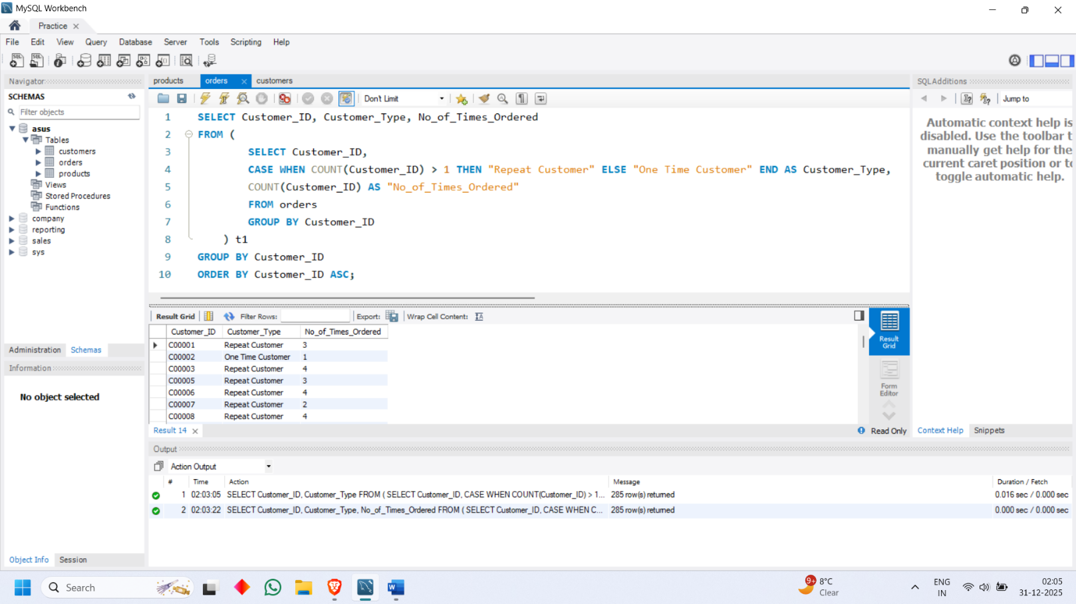

* Customer Tenure vs Spending

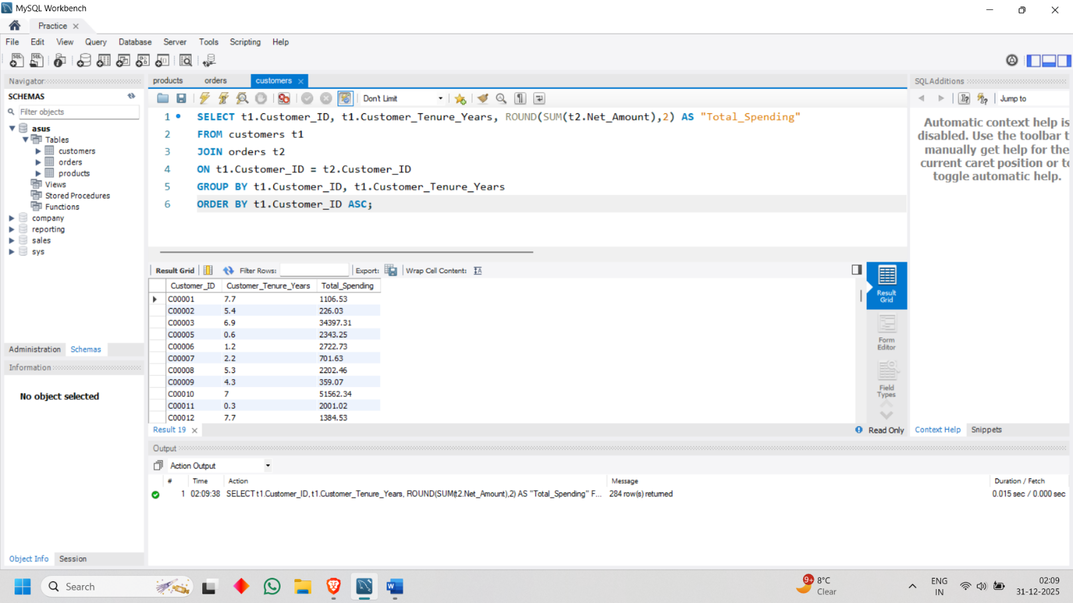

* Age Group vs Sales

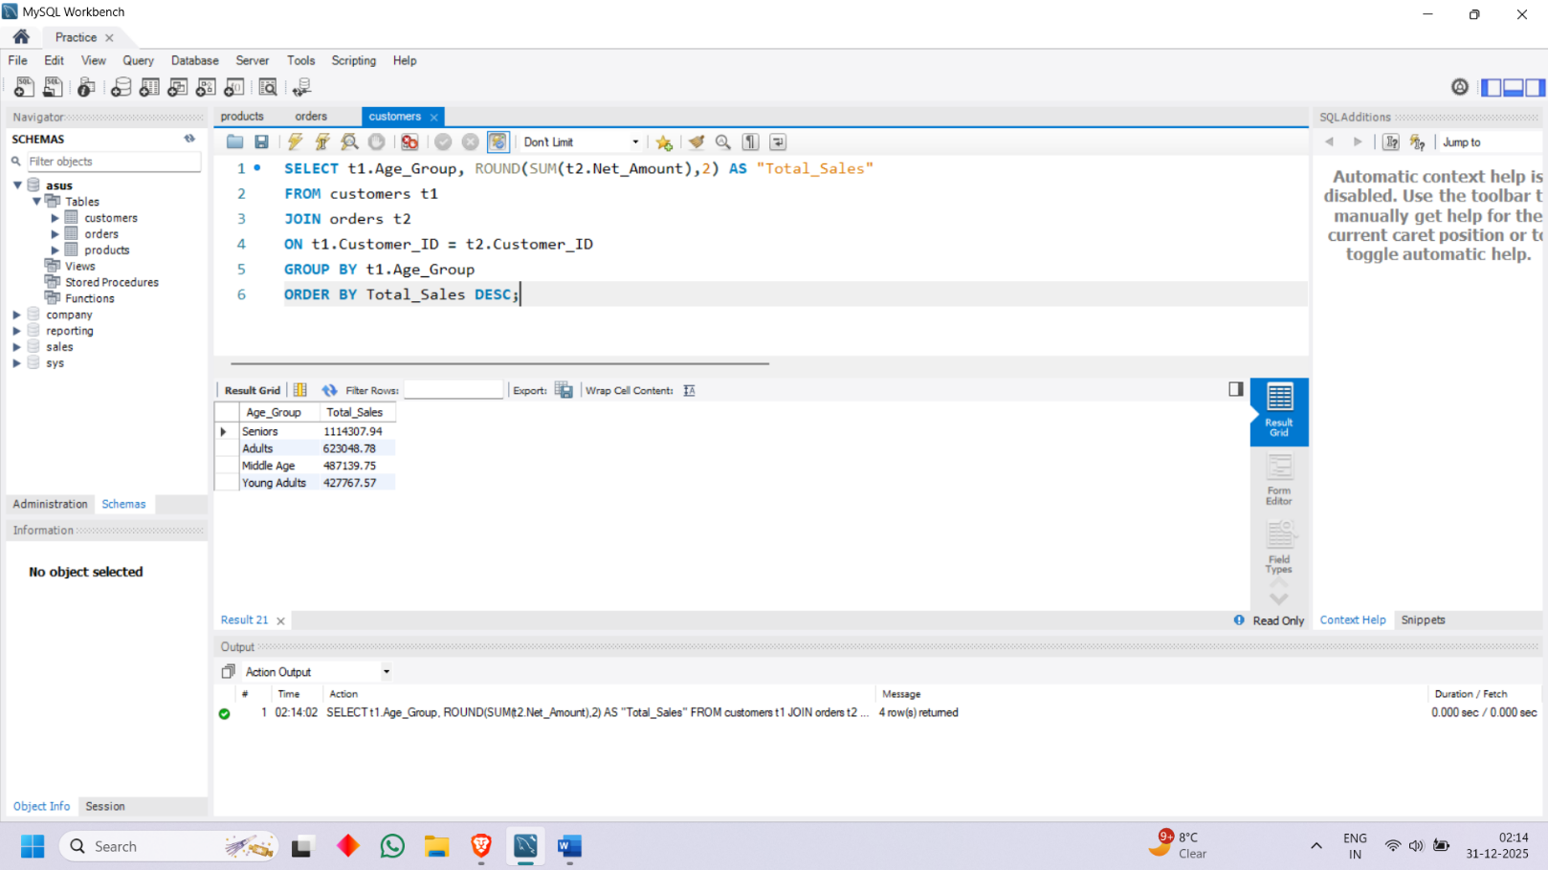

PRODUCT PERFORMANCE ANALYSIS

* Best Selling Products (Quantity)

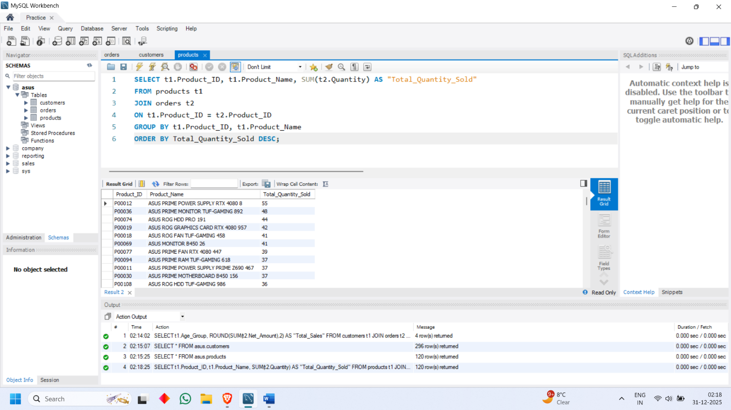

* Highest Revenue Products

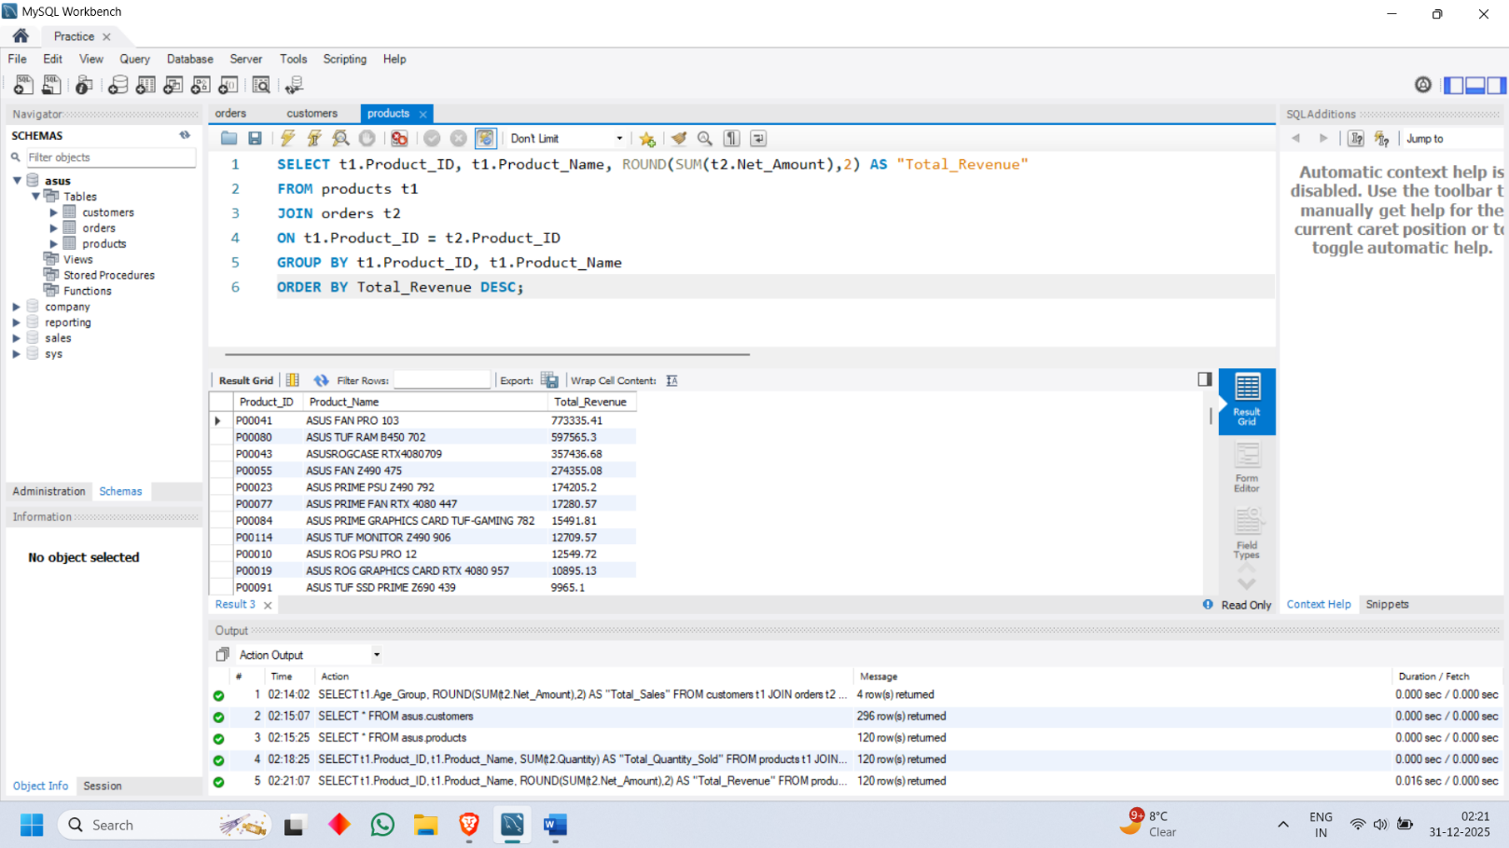

* Slow Moving Products

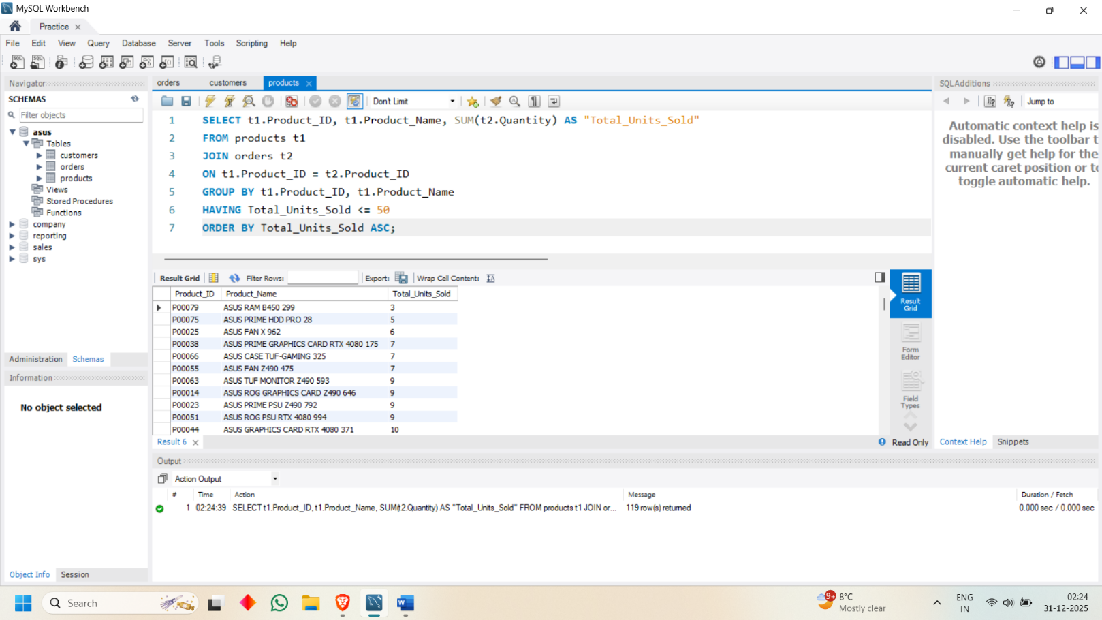

* Product Category Performance

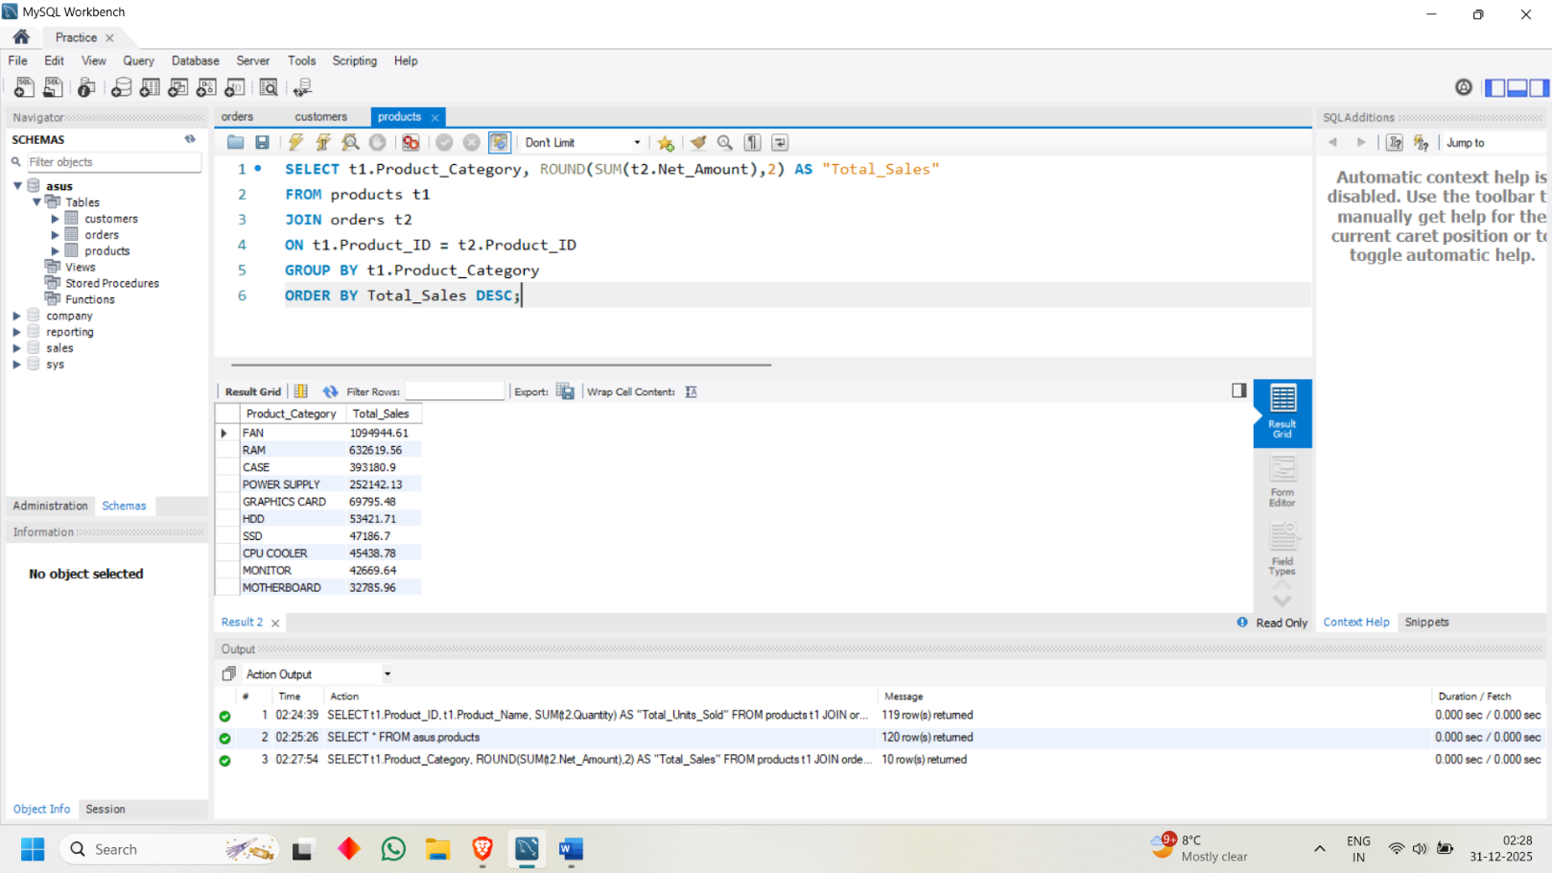

* Supplier Wise Performance

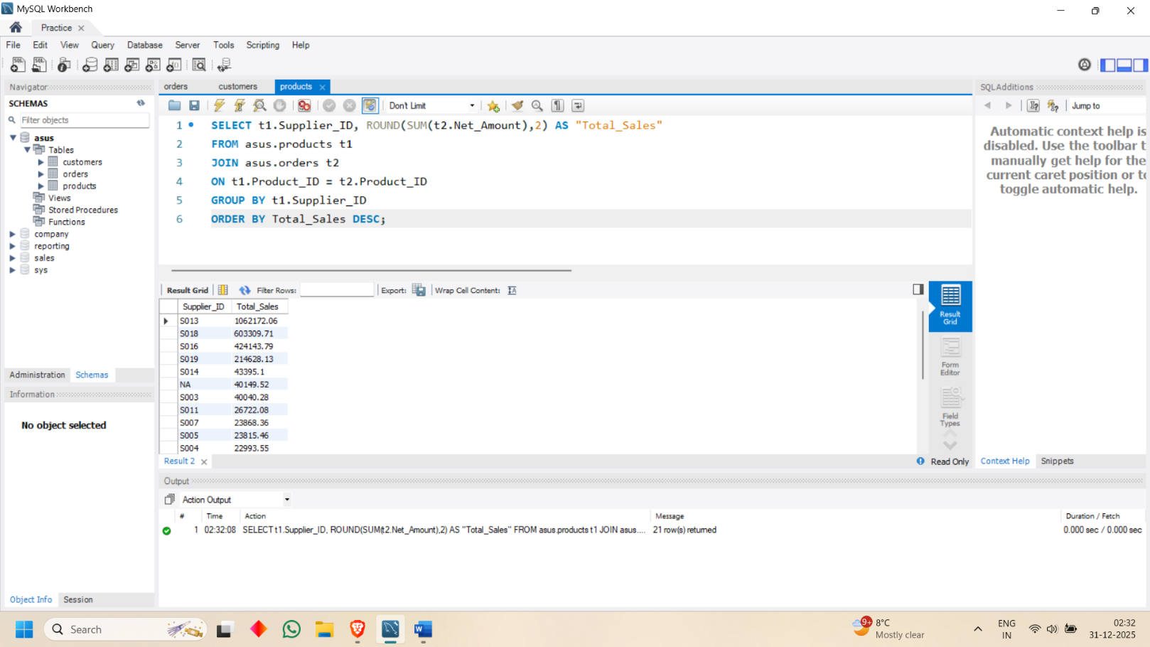

* Stock Status vs Sales

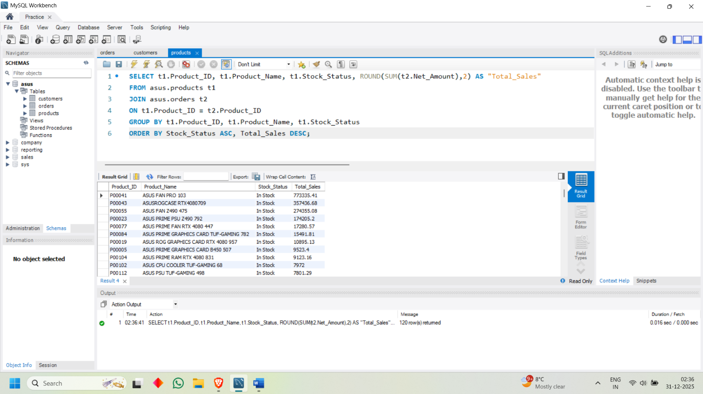

* Top Rated Products

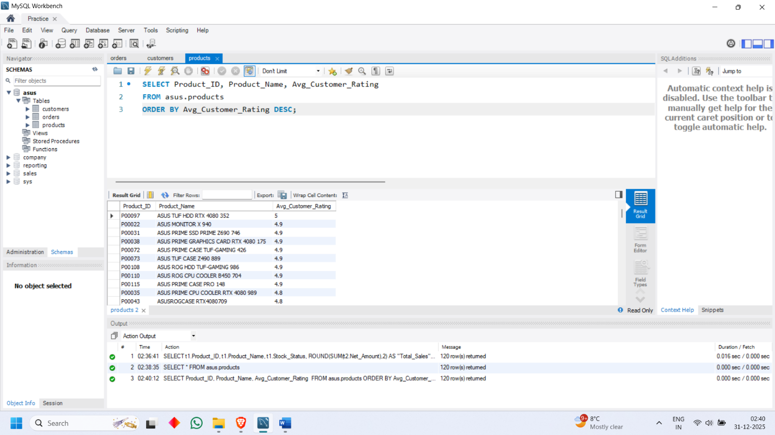

* Product Lifecycle Trend

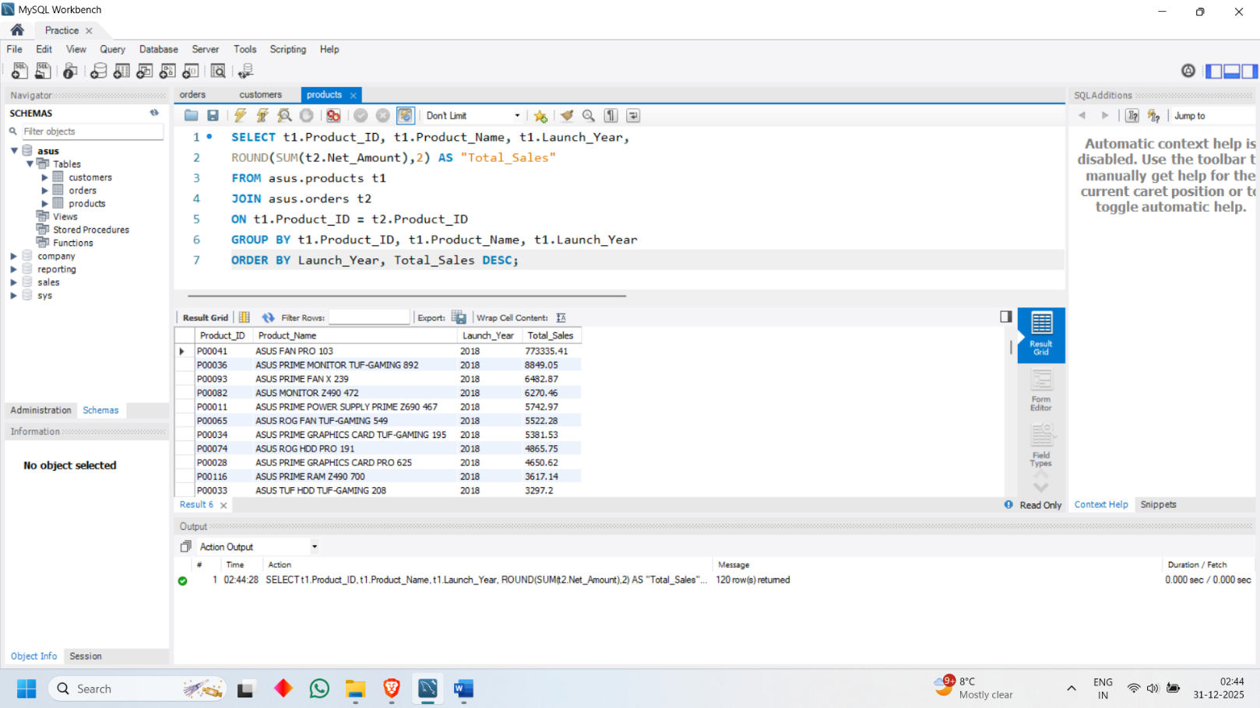

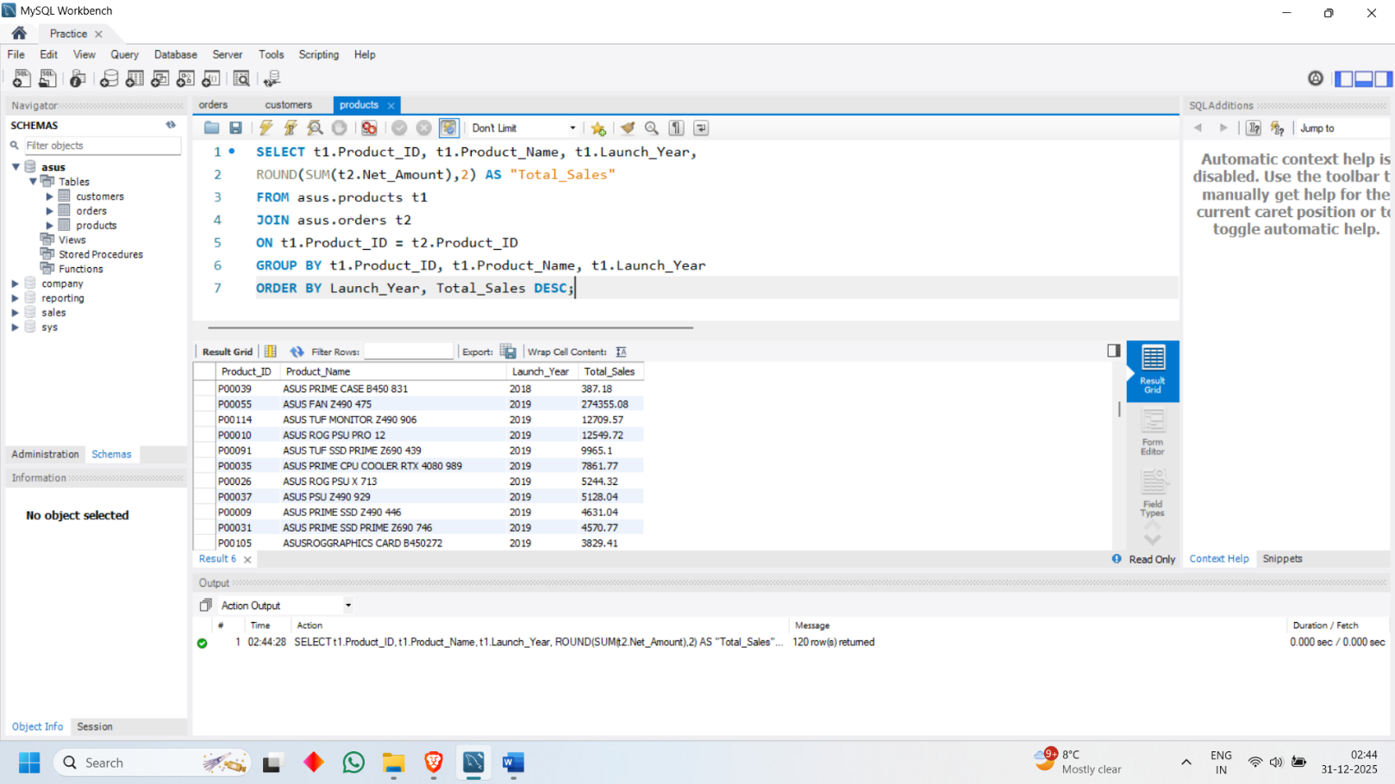

* Contribution % of Each Product

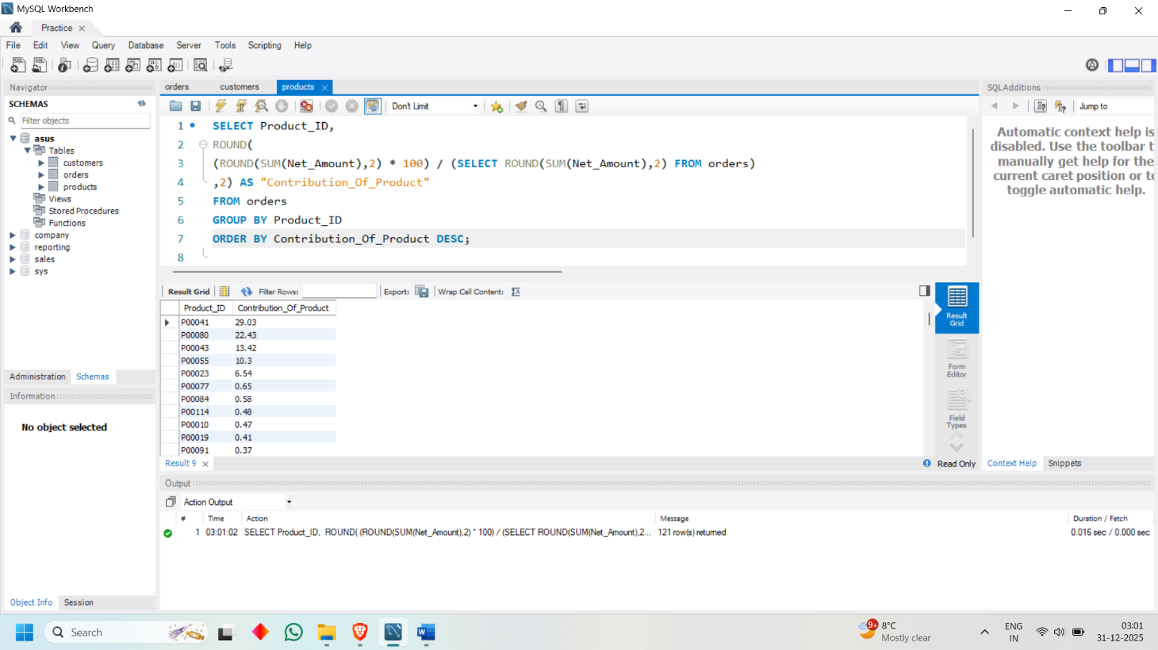

PRICING & PROFITABILITY ANALYSIS

* Average Price by Region (Average Unit Price)

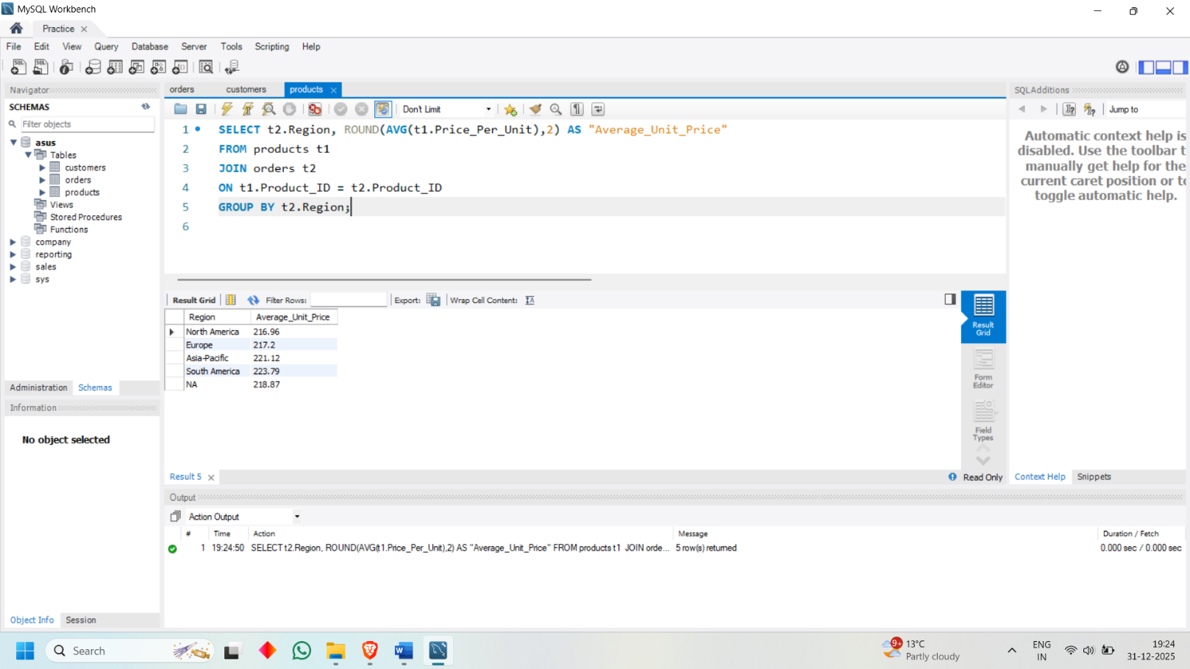

* Premium Products

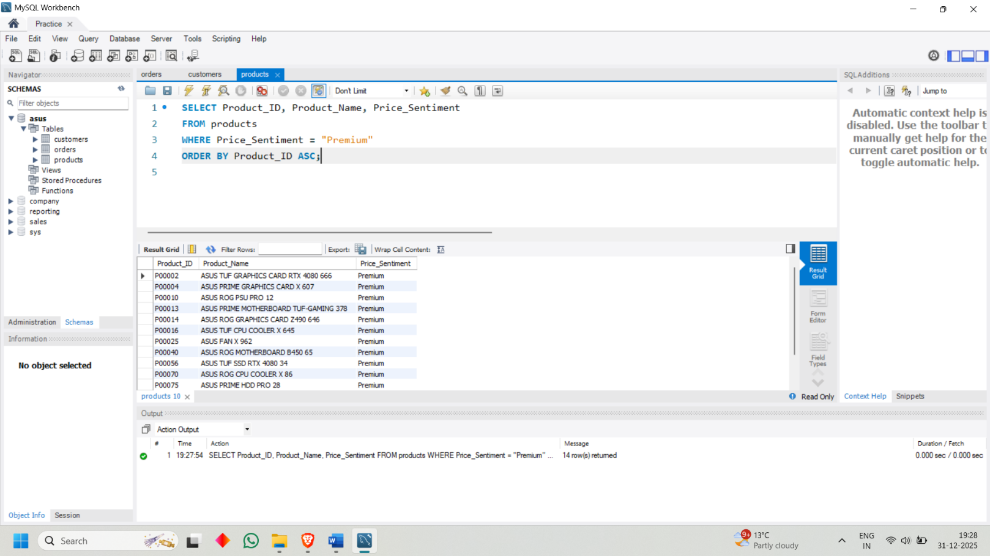

* Competitive Products

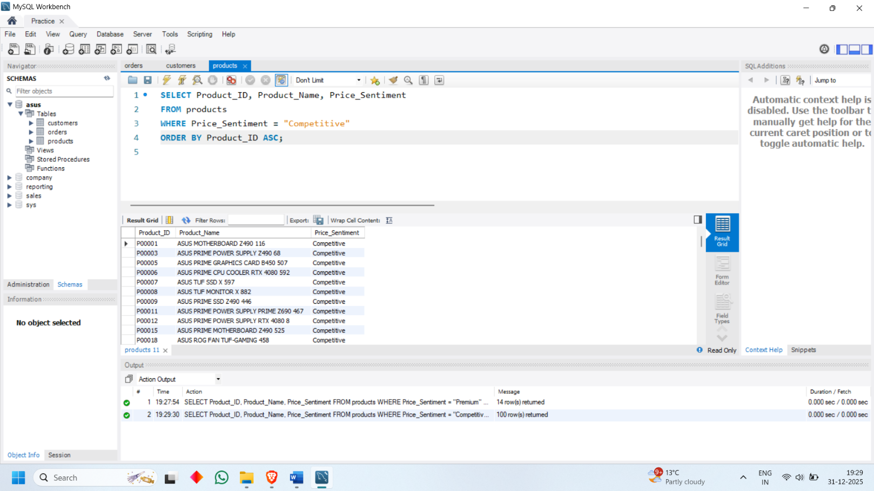

* Discount Impact on Sales

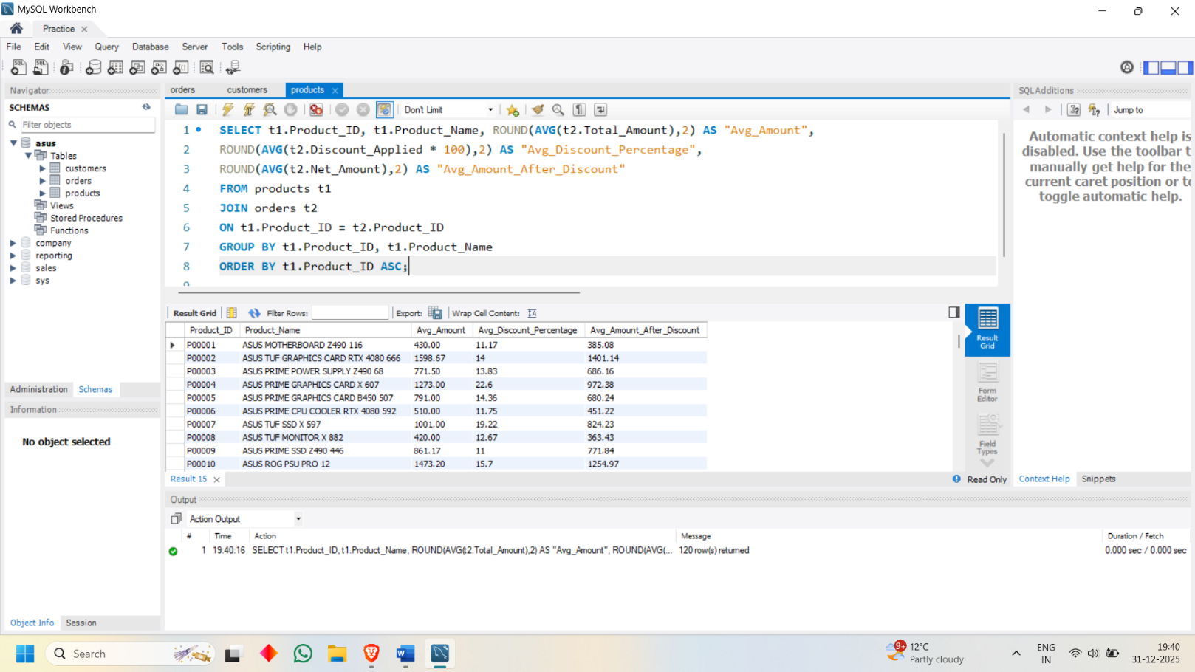

* Pricing Perception by Customer Segment

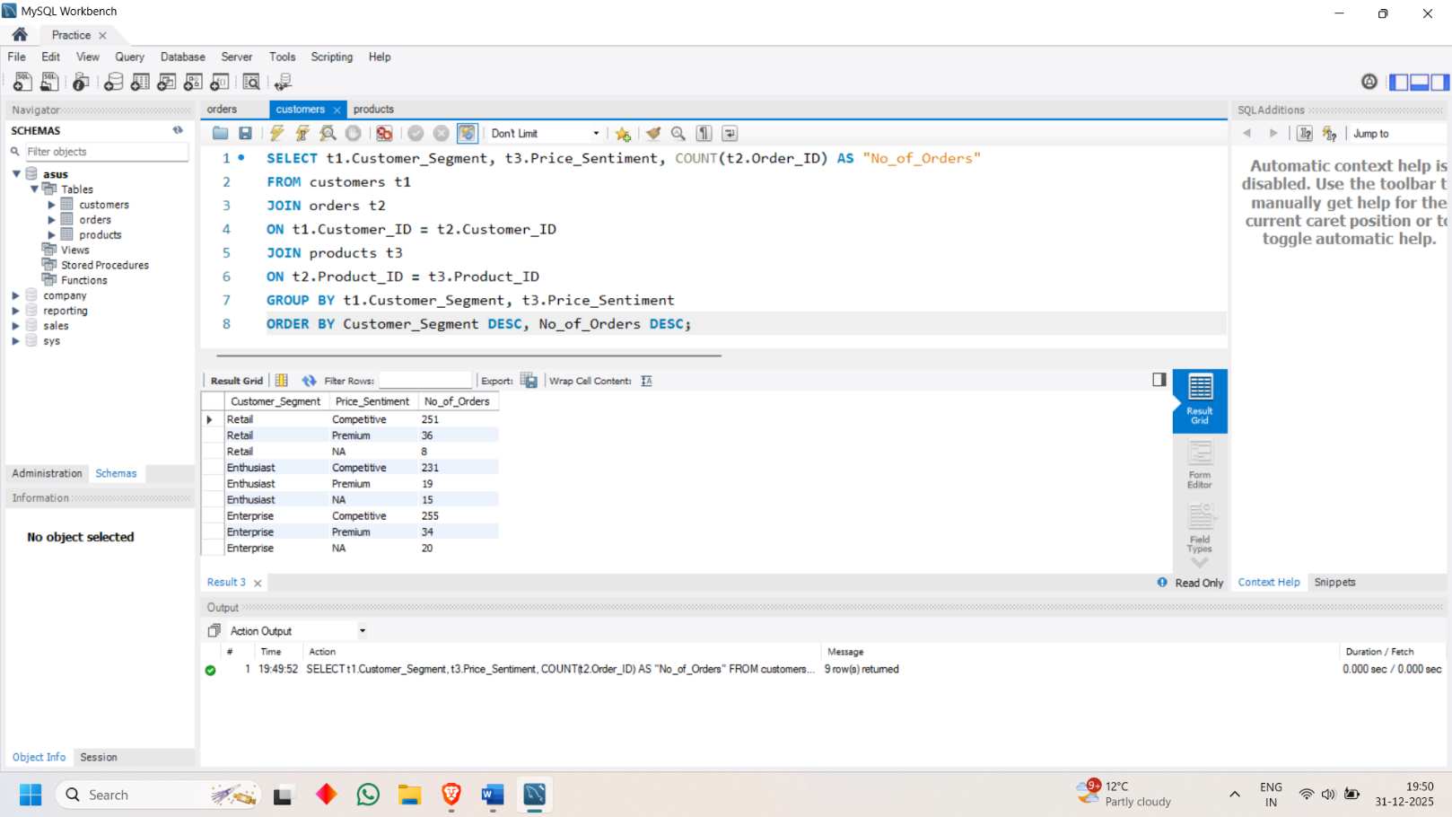

* Profit Margin by Product

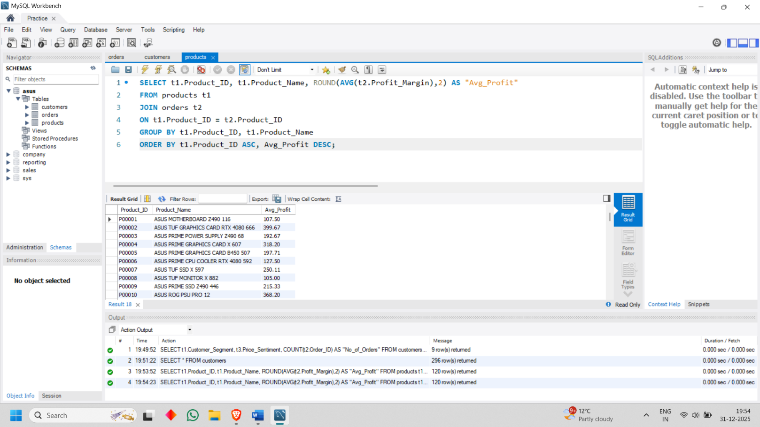

SENTIMENT ANALYSIS

* Sentiment Score by Product

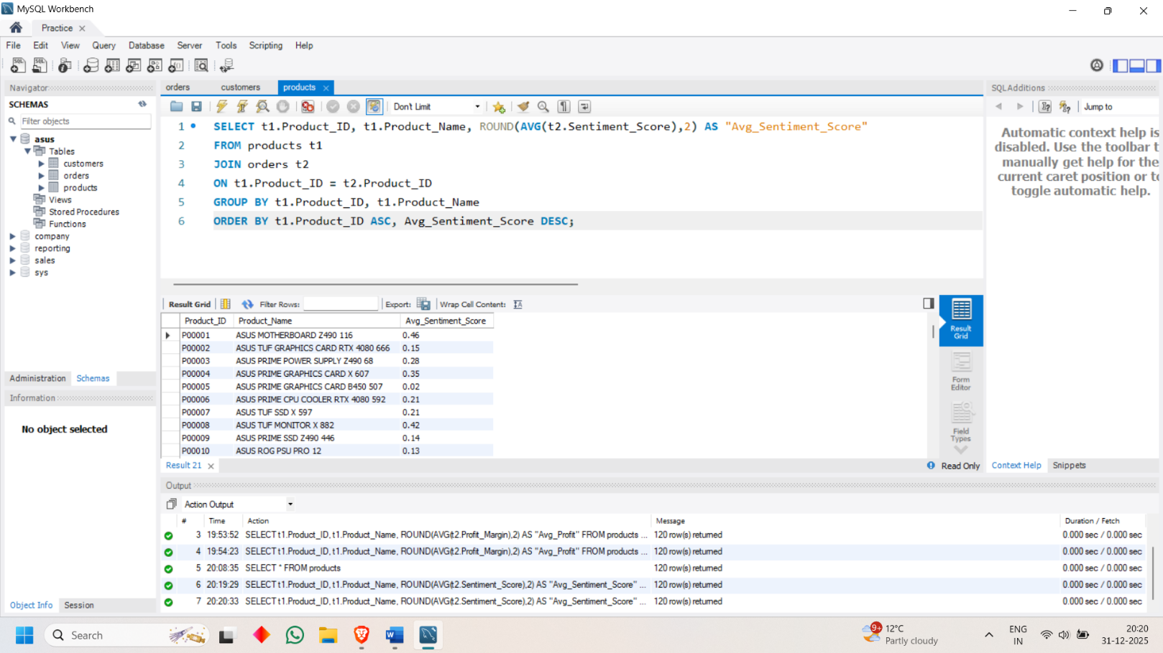

* Discount vs Sentiment

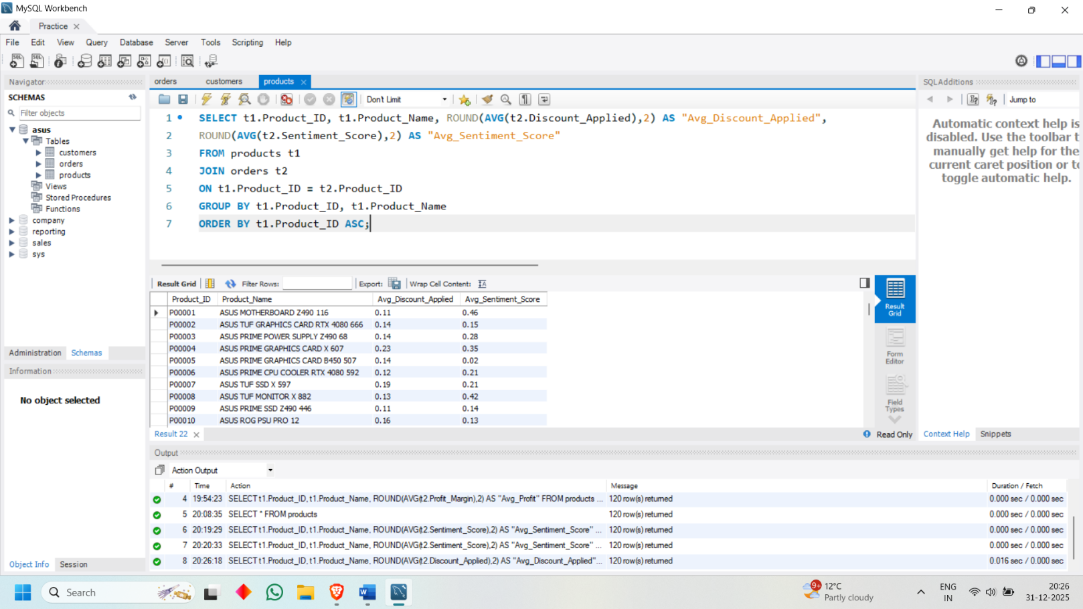

* Price Sentiment vs Customer Sentiment

